The fifth SEEDI International Conference
Digitization of cultural and scientific heritage,
May 19-20, 2010, Sarajevo, BiH

Astronomical heritage in NCD Virtual Library

Nadežda Pejović*, Žarko Mijajlović**
* Mathematical Faculty, Univ. of Belgrade nada@matf.bg.ac.yu
** Mathematical Faculty, Univ. of Belgrade, zarkom@matf.bg.ac.yu

Virtual Library, http://elib.matf.bg.ac.rs:8080/virlib

Virtual library of the Mathematical Faculty of the University of Belgrade is the largest digital depository of digitized texts in Serbia available to the general public. At this moment it contains about 800 digitized books. In the last two years more than 600 digital copies of books were uploaded in the library. There are several important collections, including 360 doctoral dissertations in mathematical sciences most of them obtained at the University of Belgrade. There is also the collection of old Serbian books dating the XVIII and XIX century. Most of these books are rare and some of them are left only in one known printed copy and they are not easily accessible.

In this talk we shall present the collection of Serbian astronomical books in astronomy printed in the XVIII and XIX century for which there are digital copies in the Virtual Library.

Astronomical books in Virtual Library

In the library there are about 50 books by the following authors

Ruđer Bošković (1711-1787), Elementorum Universae Matheseos - tomus I-III, 1757, Venetis.
Zaharije Orfelin (1726-1785), Eternal Calendar , 1783, Vienna.
Atanasije Stojković (1773-1832), Physics, 1810, Budapest.
Đorđe Stanojević (1858-1921), most of his books, 8 of them are digitized including:
The starry sky of independent Serbia.
Milan Andonović (1849-1926), Cosmography, 1888, Belgrade.
Kosta Stojanović (1867 - 1921), Atomistics by Ruđer Bošković, 1892, Niš.

Besides books from the XVIII and XIX century there are also the following astronomical books printed in the XX century:

Nikolai J. Zinger, (1842-1918), Lectures on Astronomy, 1925, Belgrade (translated by S. P. Bošković, the general and professor of geodesy at the Serbian Military Academy, edition 1899).
Milutin Milanković (1879-1958), most of his books, 10 books are digitized, including Celestial Mechanics, Belgrade, 1935 and Kanon Der Erdbestrahlung, Belgrade, 1941.
Pavle Vujević (1881-1966), Fundamentals of the mathematical and physical geography, 1924, Belgrade.
Vojislav Mišković (1892–1976), most of his books, 10 books are digitized, including Cosmography, 1931, Belgrade and Collection solved problems in general astronomy, Part I, 1956, Belgrade; Part II, electronic edition, Virtual Library, 2009.
Tatomir Anđelić (1903-1993), Astrodynamics, 1983, Belgrade.
Zaharije Brkić (1910-1979), General astronomy, 1971, Belgrade.
Branislav Ševarlić ( 1914-2001 ), General astronomy , 1971, Belgrade.
Jovan Simovljević (1929- 2007), Collected works, electronic edition, Virtual Library, 2010.

Ruđer Bošković (1711-1787)

Ruder Bošković is the greatest mathematician and astronomer of Dubrovnik, one of the most important scientists of his time, included among 100 the most important Serbs of all time. He was a university professor, founder of the Milan Observatory and director of the French Navy Optical Institute. He was a universal creator: philosopher, mathematician, astronomer, physicist, geologist, architect, archaeologist, designer, an optician, diplomat, writer, professor, poet and polyglot.
He was born on 18 May 1711 as the seventh child of the trader Nikola Bošković (Serb from Orahov Dol near Trebinje in Herzegovina) and mother Paula (of Italian descent, the family of Bar Betere, a famous poet from Dubrovnik). He lived mostly in Italy, where he gained the world fame. He died on 13 February 1787th.
.

He is the creator of the law of the united forces, asserting that there is no only the attracting force (Newton’s law), but that there is repulsion as well which changes as the distance between bodies changes. According to him, an elementary dimensionless particle is the source of forces and time and space, unlike in Newton’s cosmology, are relative. He is considered as the forerunner of Albert Einstein. Bošković had numerous contributions to astronomy:
- He introduced two geometric methods for determining the elements of solar rotation on the basis of observing the position of the three bodies.

- He determined the size and flatness of the Earth and discovered new comets.
- He first determined (1782) the exact path of Uranus based on the measurement of coordinates of Uranus. At that time it was believed that Uranus is a comet.
- Calculating the path of Uranus, he perfected a method for determining the orbits of comets on the basis of four measured positions, which was one of the most accurate methods at that time.
- He studied the atmosphere of Jupiter and the nature of Aurora.

Ruđer Bošković published numerous papers in mathematics, astronomy and physics. His famous books are Theoria philosophiae naturalis redakta ad unicam legem virium in natura existentium, Opera partinentia ad opticam et astronomia, Elementorum universae matheseos. In Virtual there are his books:
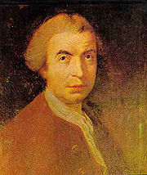

Elements of Mathematics (Elementorum Universal Matheseos - Tomus I-III, 1757, Venetis).

Diary of the way from Constantinople to Poland (1762), translated by D. Nedeljeković, 1937, Belgrade.
A law of continuity and its consequences in relation to the basic elements of matter and their forces, 1754, translated by E. Stipanić, 1975, Belgrade

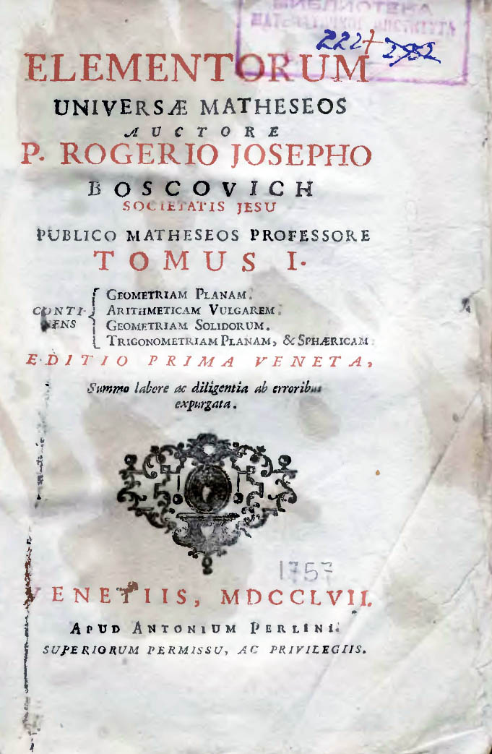
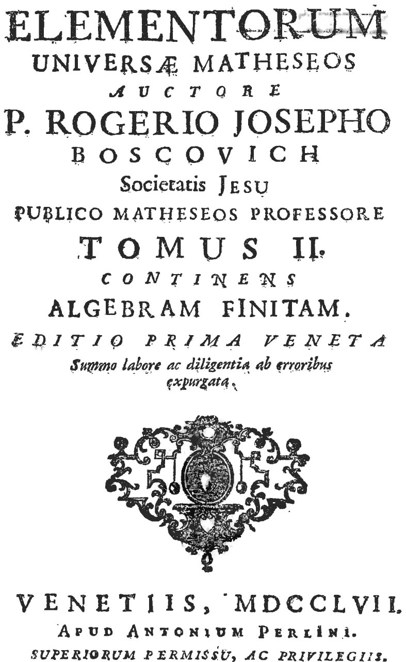

Zechariah Orfelin Stefanović (1726 - 1785) was a prominent Serbian poet, historian, engraver, baroque educator, calligrapher and writer of textbooks. He was born in a Serbian family in Vukovar (Slavonia) in 1726.
Among his most important works is Slavenoserbski magazine printed in Venice in 1768. This is the first South Slavic magazine. Although it was printed just one volume, its importance is great. In the preface he presents the idea of civil enlightenment, and also speaks that science, literature and philosophy should be to leave the narrow circle of educated people and should become available to everyone. In 1768 Zechariah Orfelin introduced into the Serbian literary a language which was a mixture of Church and peoples language, having many Russian words. In this way he practically founded Slavoserbian language.
Orfelin is the author of the first Serbian bukvar which was used since 1767 in teaching writing and reading many generations of students. He is also the author of the first Latin textbook. His most comprehensive work was The Life of Peter the Great (Venice, 1772), which he had seen as the enlightened monarch. He also wrote Perpetual (eternal) calendar printed in 1783 in Vienna. This book includes a comprehensive chapter on astronomy.
Because of his artistic works, primarily in the copperplate, he was elected for a member of the Art Academy in Vienna.

Orfelin’s Perpetual Calendar has been printed in Vienna in 1783. The book has 366 pages and 9 astronomical drawings at the end of the book. Its content is mainly on natural sciences and astronomical phenomena and contains as well description of historical events since the creation of the world chronologically presented. Chapters in astronomy bear the names: Space, The Moon and the planets, comets, solar eclipse and Moon eclipse. It includes information on weather cycles, tables with information about the Sun and the Moon (needed for the calculation of the date of Easter according to the Big indicium), tables on the length of day and night, moon phase tables, and more. Therefore Perpetual calendar is the first book on astronomy written Slavonic language, how Orfelin says “to the benefit of the people slovenoserbskim”.

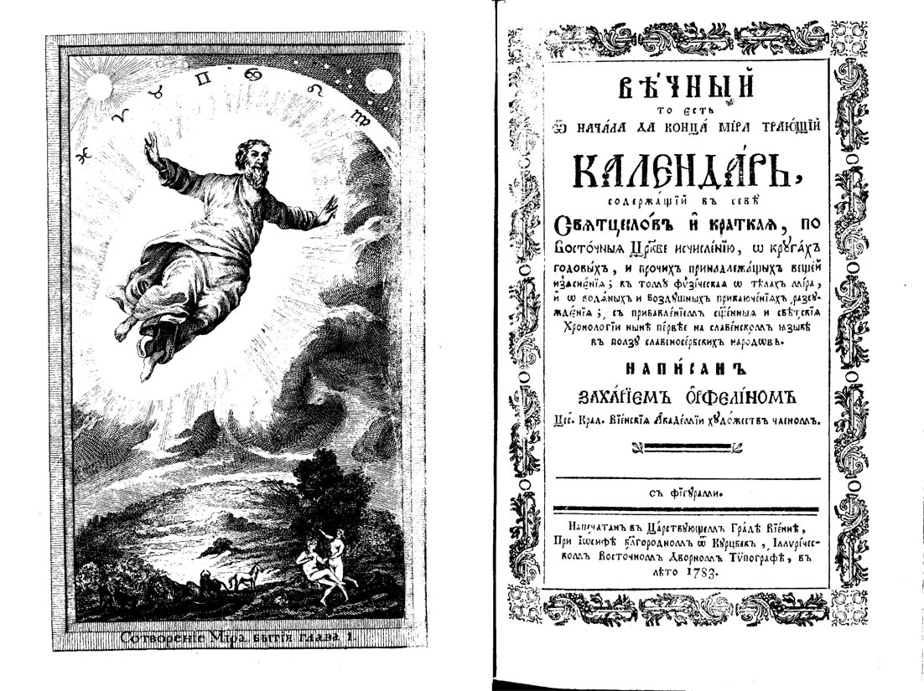

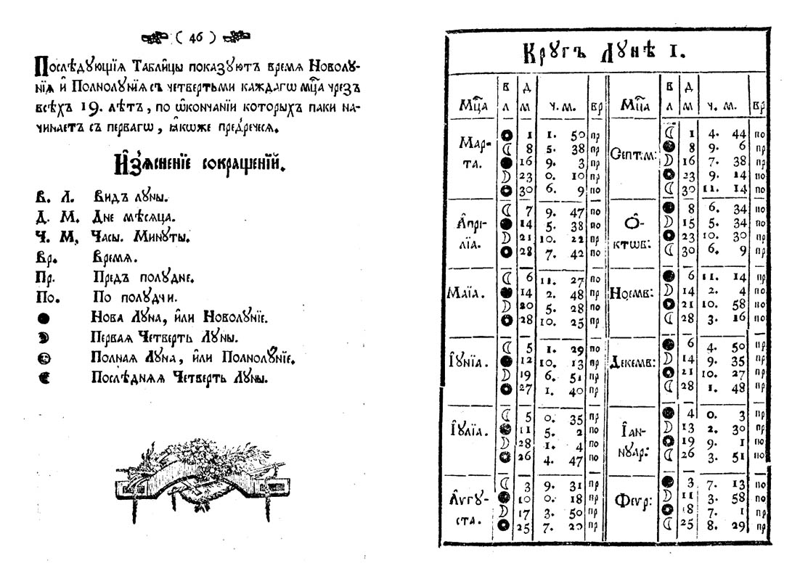

Atanasije Stojković was born in 1773. In this city he finished Ascension school (Serbian Grammar school). He went soon to Šopron where in 1794 completed the first six grades of high school and then enrolled in secondary school in Szeged, where in 1796 graduated philosophy. In Vienna, in July 1797th, he meets Dositej Obradović and introduces him self with Dositej’s enlightenment ideas. In the fall of that year he managed to get the Metropolitan Stratimirovića support for studies in Göttingen, at that time one of the most famous universities. There he obtained PhD degree in philosophy (1799), and began intensive studies in various sciences (physics, mathematics, astronomy, history). After a brief stay in Ruma (1799) he moved to Budapest, where he published his main work Physics (1801-1803), written in 3 volumes.
In the Habsburg monarchy it was difficult to obtain civil service, and by call of Severin Osipovič Potocki, the future Minister of Education of Russia, Atanasije accepted the position of full professor of physics at newly established Kharkov University. He soon became the dean of the department of physics and mathematics and in two occasions (1807-1808 and 1811-1813) Rector of the University of Kharkov. He is the founder Kharkov Learned Society and received many honors. He became a member of the Imperial Academy of Sciences, obtained many material privileges, became a national consultant and Tsar Alexander I gave him the Medal of St. Vladimir of the third degree.

In Kharkov, Atanasije Stojković published numerous works written in Russian, mainly intended for students. Particularly interesting is the astronomical book О воздушних камњахи јих происхожденији (About meteorites and their origins) printed in 1807. Stojković wrote this book when he got a piece of "air stone", which fell in 1787th near the village of Harkovskoj Žigajlovka Guberniya. This book is the first work on meteorites in the world and its dissemination significantly influenced the development of science on meteorites. In Tunguska area, where on 30 June 1908 the famous large meteorite exploded, there is a hill 150 meters high, which is named after the scientist – Stojković’s hill. It is planned a digital copy of this book for the Virtual Library. A hard copy of the book is in the Museum of the Serbian Orthodox church in the Patriarchate in Belgrade.

In addition to these books Stojković also wrote the following two books, both published in 1813:
Началнија основанија физическој Географији (Basics of physical geography).
Началнија основанија физическој астрономији (Basics of physical astronomy).

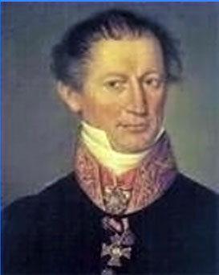

Atanasije Stojković was a worthy and capable man, of wild spirit, very successful and appreciated. He spoke several languages: German, Latin, French, Italian, English, Greek, Hungarian, and almost all Slavic languages. He had interesting and exciting life that next to science was marked by an affair that ended his professorial career. He was also engaged in a secret mission and diplomacy. He died in Kharkov in 1832.
With his versatility, ambition and intelligence, probably under the influence of enlightenment ideas of Dositej Obradović, Stojković was trying to enlighten his people, to improve their science and culture, at a time when barely was foreseen the emergence of a new Serbian state.

The Stojkvićev’s book Фисика (Physics) was printed in 3 volumes. The first two volumes have 320 pages while the third was written in 284 pages. The book presents an overview of the knowledge at that time of nature and natural phenomena. At the beginning of the first volume is the chapter on mechanics (the properties and movements of the body). Most of the first volume (the second and the third chapter) is devoted to astronomy. There are described celestial bodies, apparently moving spheres of the sky, stars, solar system, Sun, planets, comets, Moon, eclipses. The third chapter describes our planet Earth. Also, the concepts of celestial equator, horizon, zenith, and nadir are introduced, then the geographical coordinates, the size of Earth, the Earth's movement, the inequality of the day and night on Earth and the Earth's interior. The rest of the book is devoted to the description of geographical notions and meteorological phenomena. .
The book is written in the people’s language, without complex mathematical formulas and equations, with the aim to present knowledge about astronomy and nature to ordinary people.

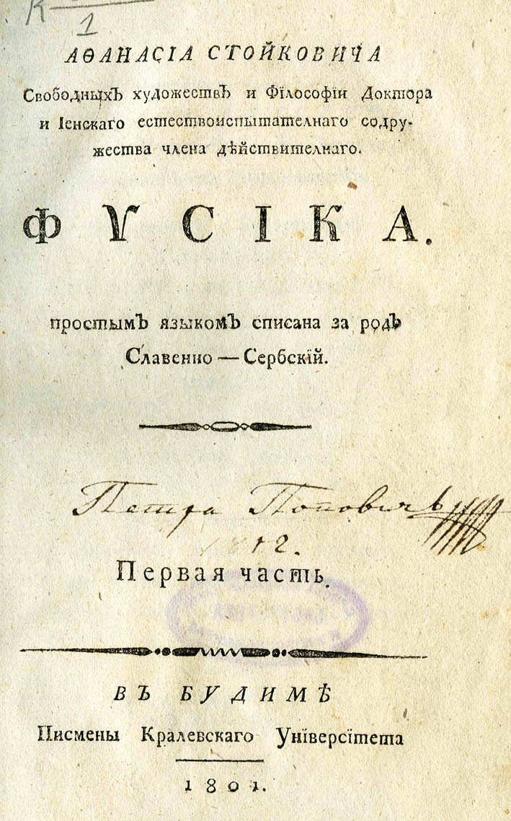
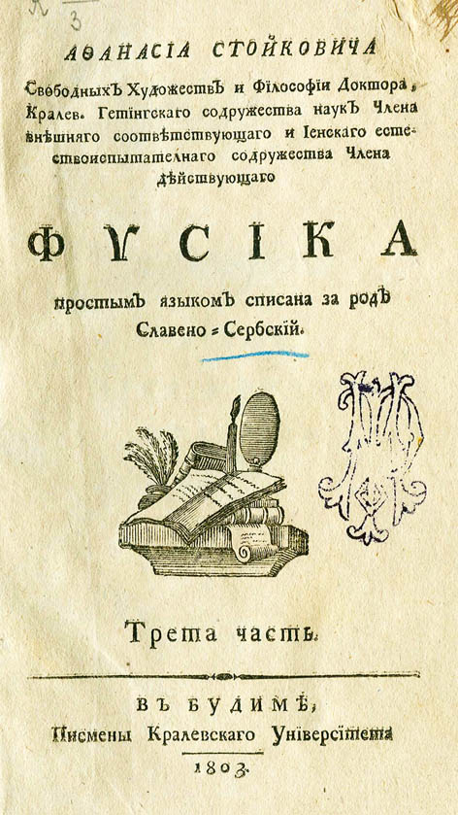

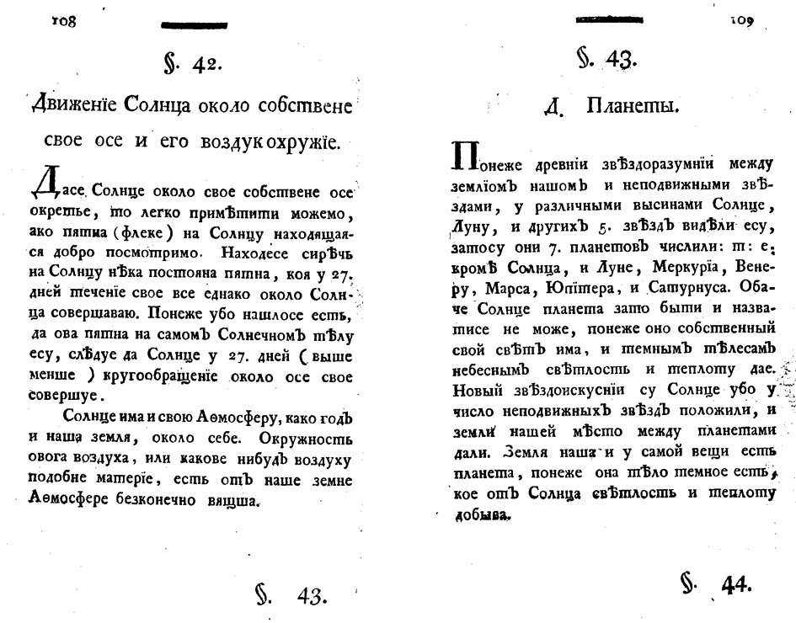

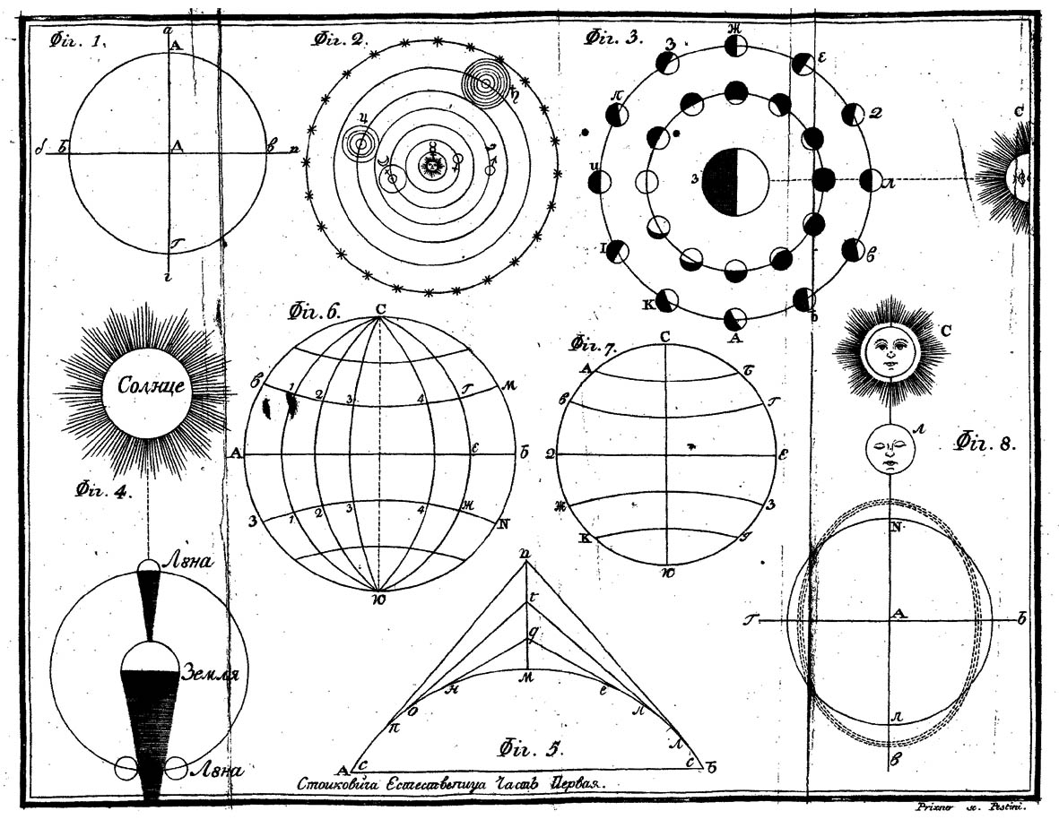

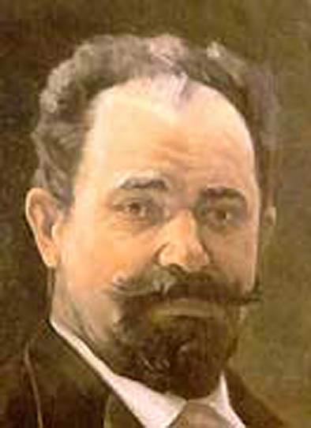
Đorđe Stanojević (1858-1921) was born in Negotin. He completed the Great School in Belgrade. After that he became the asistent at High School, working with his teacher Alkovića Kosta (1836-1909) and then the professor at the First Belgrade Gymnasium (1883). Having the scholarship of the Ministry of Defense from 1883 to 1887 he studied in the most famous astronomical and meteorological observatories in Europe (Potsdam, Hamburg, Medon, Greenwich, Pulkovo). On behalf of his results he received a call from the Paris Observatory to participate in scientific research expedition to study the Sun and in the Petrovsky where he participated in the study of the full eclipse of the Sun, and two years later and in other scientific-research expedition to study the Sun and the thermal spectrum in Sahara. At that time, and later, he published several research papers in astronomy in the editions of the Paris Academy of Sciences. These are the first scientific work in astronomy among Serbs

Stanojević was a versatile, knowledgeable man with a lot of active interest in many fields of science and technology. His interest in physics was great. Upon his return to Serbia he devoted himself to the study of modern physics. At the same time, he became the lecturer in physics and mechanics at the Military Academy. Also, he taught applied physics and mechanics at the High School and at the Belgrade University after establishing it in 1905. He was responsible for the construction of hydroelectric power plants in Serbia (Vučje, Negotin, Užice, Ivanjica and other places) and for the electrification of Belgrade. This put Belgrade among the first European capitals with full electric lighting. He died in Paris in 1921.

In Negotin there is Square “Đorđe Stanojević” and the museum dedicated to him. In New Belgrade there is the street “Đorđe Stanojević”. Electric Power Industry of Serbia on the occasion of his day, 6th October, gives recognition “Đorđe Stanojević” for contributions to the development of the Serbian electric power industry.

The Virtual Library contains eight digitized books of Đorđe Stanojević:
The starry sky of independent of Serbia, 1882, Belgrade
A walk through the clouds, 1884, Belgrade
Cosmic energy of modern physics (introductory lecture, 22nd September, 1887, Department of Physics at the Military Academy in Belgrade)
Nikola Tesla and his discovery, 1894, Belgrade
Science of light, 1895, Belgrade
Central forces in nature, 1906, Belgrade.
Industry of coldness, 1909, Belgrade
Inaccurate knowledge of the Resurrection in the Orthodox Church and the reform of the calendar, 1908, Belgrade

Stanojević’s book The starry sky of independent Serbia is one of the first books on astronomy written in Serbian. The book was issued by Royal-Serbian state printing shop in 1882 in Belgrade. The hard copy of the book is in the University Library of Belgrade, recorded under inventory no. 13006. The book is small in volume but its content is a real pearl of our scientific literature of the nineteenth century. Đorđa Stanojević taught schools in European centers and had a good knowledge of foreign languages, so he wrote the book using the then available literature. In the preface Stanojević mentioned two French and one German book.

The book has 70 pages, consists of a preface, ten chapters, a star map and has 22 pictures. The book consists of chapters: Stars in general, Astronomical division of the sky, Number, distance and size distribution of stars, Star maps, Star clusters and their stars, Change of the sky due to precession, Nutation, aberration and refraction, Proper motion of the stars, Variable and new stars double stars, Star clusters and the Milky Way.

Although this book is not large, according to the names of chapters we can conclude that the reader of that time could gain a solid insight into astronomy. Astronomical concepts are explained in a simple and transparent way with the beautiful language and with nice accompanying drawings and illustrations. Stanojević gave special attention to the starry sky, the constellation descriptions, orientation in the sky by use of constellations and usage of star map.

We emphasize the fine writing style and clear exposition of often complex astronomical phenomena. They are described mostly without mathematical expressions using very fine graphics. Therefore, this book has educational aim and is intended mainly for the general readers. We can say, in this regard, Stanojević achieved his goal. It is our great pleasure to bring this precious book out of the darkness of library’s storage into the light and made it easily accessible to the readers through the Virtual Library.

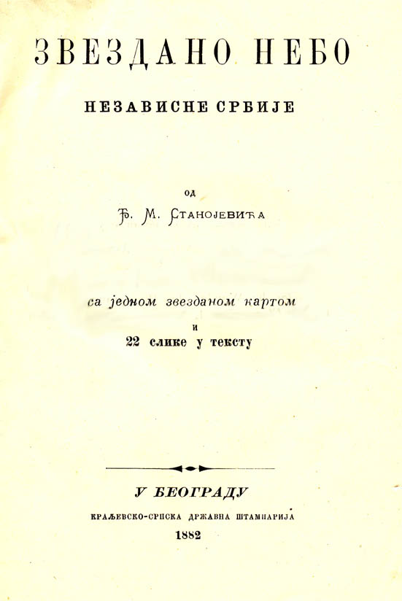

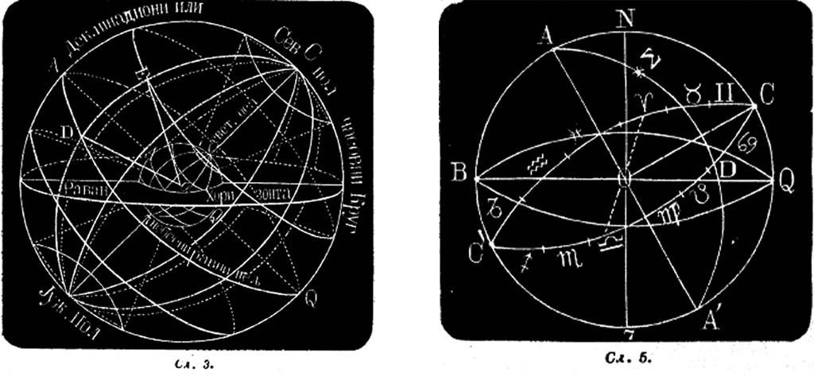

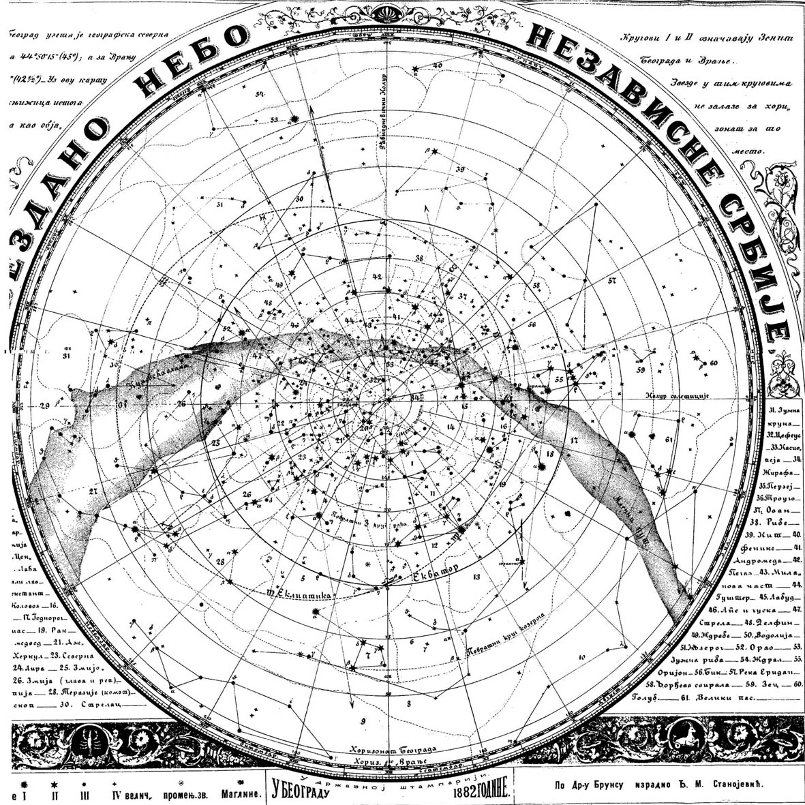

Milan Andonović (1849-1926) was born in Požarevac where he finished high school. He was educated in Belgrade at the engineering departments of the Great School in Belgrade and at the German Universities in Karlsruhe, Aachen and Munich under supervision of famous professors Ritter, Jordan, and Helmert. There he specialized in mechanics, geodesy and astronomy. Upon his return to Serbia in 1880, he was appointed professor of geodesy at the Great School. He was responsible for the introduction and enforcement of the cadastre in Serbia in the late 19th century. He founded the Geodetic Institute under whose auspices at that time were surveyed many towns in Serbia. In 1907 he founded the Surveying and Building Academy where they trained many Serbian surveyors and builders. Together with John Dragašević, Milan Nedeljković and Djordje Stanojević he is bearing the credit for introducing the teaching of astronomy in Serbian schools and promotion of science in Serbia. He died in Vienna in 1926.
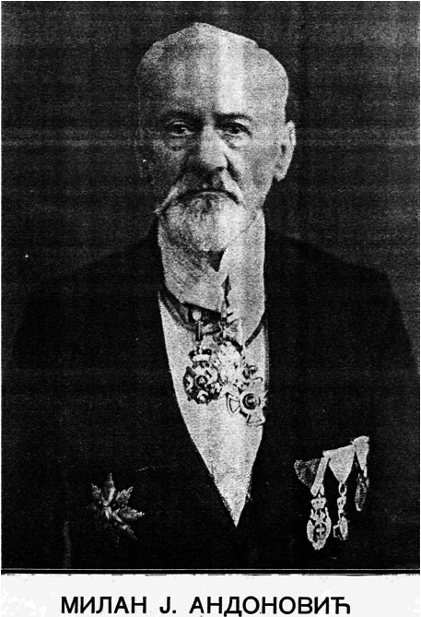

Andonović has published a large number of scientific papers, books, and discussions related to surveying, astronomy, shape and size of the Earth, the theory of least squares, survey and cadastre:

Basics probability and the theory of least squares, 1886, p. 263.

The shape and size of the Earth, 1886, p. 34;

Cosmography with basic astronomical notes for high school teachers, 1888, p. 533

The volume and size of our Earth, 1889, p. 46

The Universe, 1889, p. 30

Basic geodesy with distinctive view of the cadastral question, 1890-1897 (1st part 1890, p.368, 2nd part 1897 vol. 1, p. 369-1390; vol. 2, p.1391-1641)

The cadastre, 1889, S. 83
He also wrote during the First World War, political discussions and articles (in German and French) in the favor of Serbia.

There are the following digital copies of his books in the Virtual Library:
Cosmography, 1888, Belgrade
The Universe, 1889, Belgrade
Hard copies of both books are in the Library of Astronomical Observatory of Belgrade. Books are digitized by the courtesy of Vojislava Protić-Benišek.
Cosmography was intended for high school students and students of other secondary schools. Probably, it was used as a secondary textbook at the Military Academy and the Grand School, the forerunner of the Belgrade University. In addition to the foreign literature, Andonović mentioned in the bibliography two Serbian authors: Trigonometry of Dimitrije Nešić and Cosmometry from Jovan Dragašević. The book has many illustrations: 141 photos and drawings, 17 tables and a large star map. Most of the items were taken, with permission, from a book of E. Weiss, then the director of the Vienna Observatory.

Cosmography is extensive (533 pages) and quite comprehensive book. Thus, it describes celestial sphere, constellations, the shape and size of the Earth, the Earth's rotation and revolution, the apparent movement of the Sun, coordinate systems, time, calendars, Solar system, stars, tides, precession, Cosmogony and among other things, Kant-Laplace's theory about the origin of the World (i.e. the Solar system). Besides all this, there are twenty fully solved problems with detailed explanations.

The book is written in very beautiful style, almost as a literary work, and is worth reading also from that point of view. There we find many forgotten words and terms whose meaning has changed today. For example, cluster (serb. zvezdano jato) there means constellation, stardust (serb. ozvezdina) - meteorite, comet star (serb. zvezda repatica)- comet, the inflow and outflow (serb. priliv i odliv)- tide. Also, for each constellation he introduces alinjman – having the meaning similar to asterism. For example alinjman Big Bear (in Serbian also called Velika kola - Big Chariot) has four stars – the asterism trapeze of the constellation Big Bear, while the alinjman North Star is the line that passes through the rear wheels of the Big Chariot toward to the North Star..

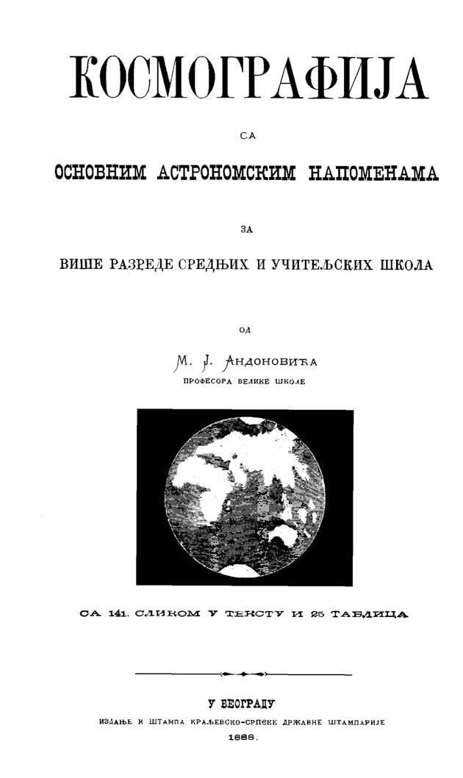
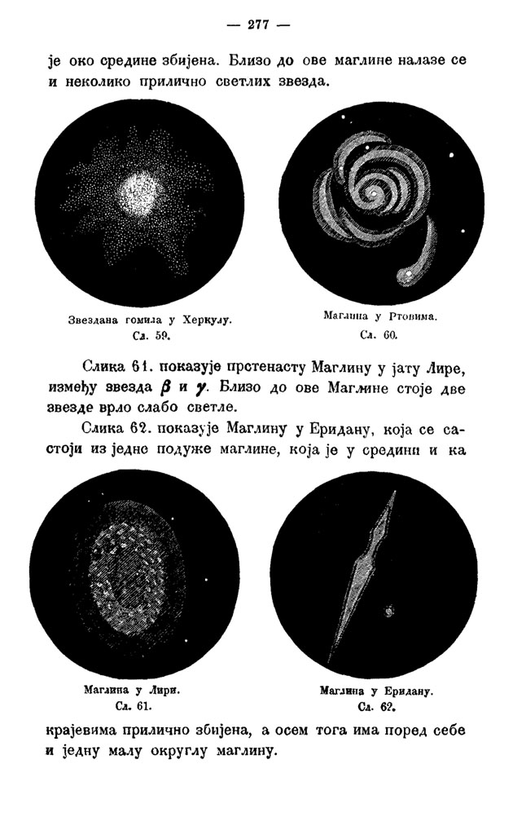

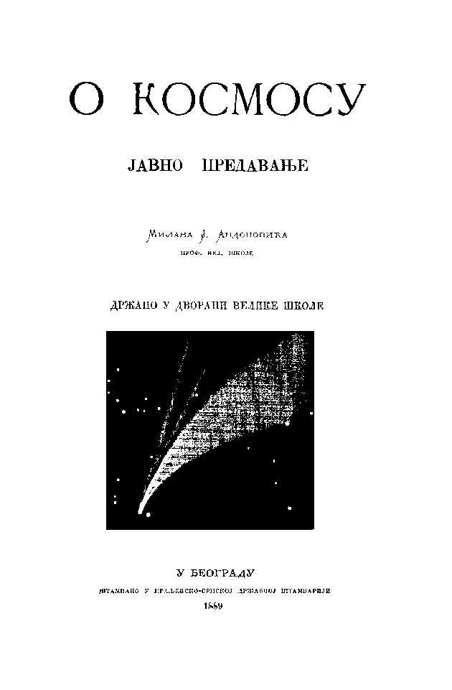

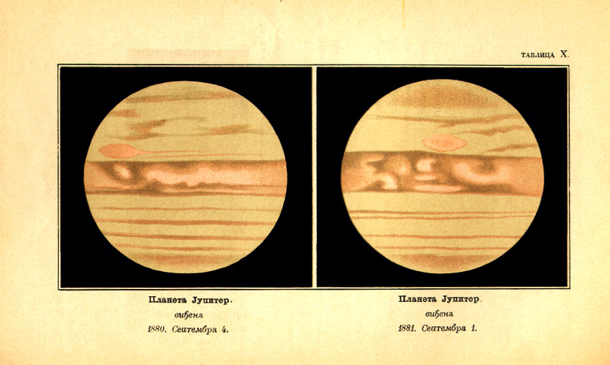

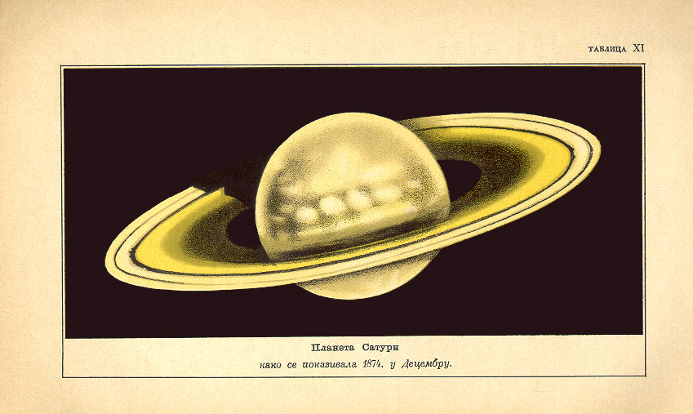

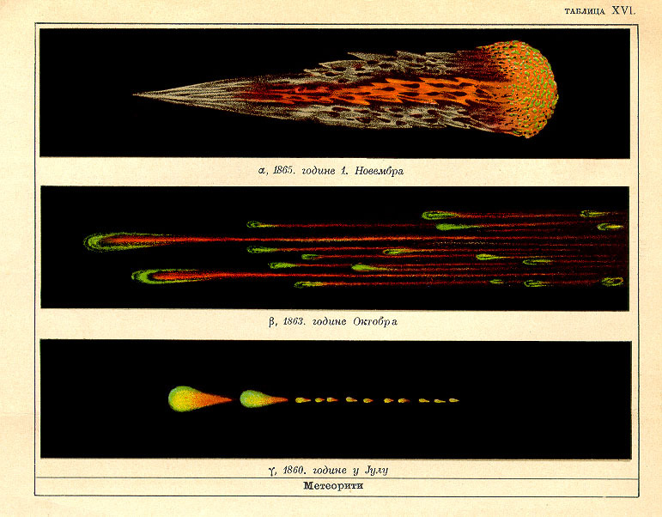

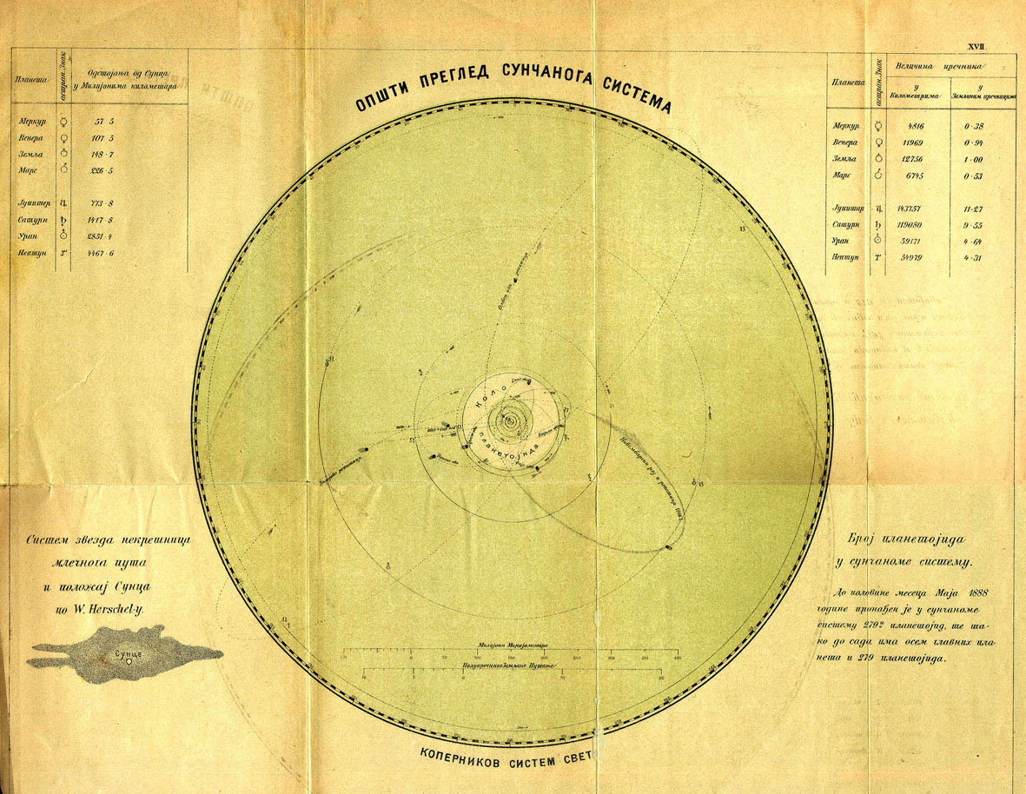

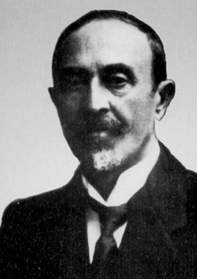
Kosta Stojanović (1867-1921) was born in Aleksinac. There he finished elementary school and lower secondary school, while the high school he completed in Niš. He graduated in mathematical sciences at the Grand School in Belgrade. For some time he was working as a high school teacher in Niš and Belgrade. He went to Paris in 1893 where he taught mathematics, astronomy, mechanics and physics under supervision of famous professors Poincaré, Picard and Appeal. There he became a member of the Historical Society of France and the French Astronomical Society. In Leipzig he went 1897 where he entered doctoral studies in mathematics. Unfortunately, he returned to Serbia after three months because of illness.

Kosta Stojanović besides the university had a very rich political career. At the beginning of 1900th he became a deputy as a representative of the Niš district. Since the 1903rd he taught applied mathematics at the Grand School and at the Belgrade University after it was established in 1905. Whereupon he abruptly interrupted academic career and 1906 he became Minister of Commerce, at the time of the custom war between Belgrade and Vienna.

Around that time, Kosta Stojanović wrote the book Fundamentals of economy value. This book is a work in mathematical economics and Stojanović there used very advanced mathematical apparatus, for example, the theory of partial differential equations to describe economic models. Even today there is an interest for this book, not only in Serbia but also in other parts of former Yugoslavia. This is probably the most advanced book in economics ever printed in Serbia due to the mathematical tools that were used in it.

The government of Nikola Pasic he was the Minister of Agriculture (1919-1920) and Minister of Finance in 1921. A few days after the appointment as the minister of finance, he suddenly died.

Kosta Stojanovic also published the following books:
Atomistics (of Ruđer Bošković), 1891, Niš
Mechanics, 1912, Belgrade
Treatises on science and philosophy (posthumously), 1922, Belgrade
All these three books are in the Virtual Library.

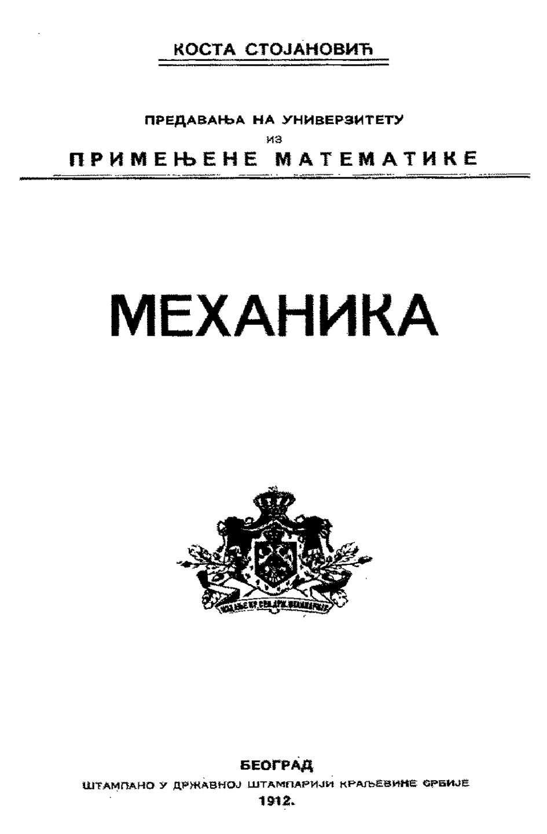

The book Mechanics is actually a university textbook in applied mathematics. Let us mention that in this time, under the term applied mathematics it was assumed mechanics, mathematical physics and celestial mechanics. Most of the books were related to the vector calculus, then the kinematics, static, dynamic, analytical mechanics and the theory of differential equations. Chapter Ten of this book is dedicated to astronomy. Here he gave the basics of celestial mechanics, then the differential equations of motion of planets, comets and satellites are presented. Also, the theory of elliptical movement, the method of variation of constants and parabolic motion of comets are given.

